**P510/3**

**PHYSICS**

**PRACTICAL**

**Paper 3**

**July / August**

**3 ¼ Hours**



**ELITE EXAMINATION BUREAU MOCK 2019**

**Uganda Advanced Certificate of Education**

PHYSICS PRACTICAL

**Paper 3**

**3 Hours 15Minutes**

**INSTRUCTIONS TO CANDIDATES:**

* *Answer* ***question 1*** *and* ***one*** *other question.*
* *You are not allowed to start working with apparatus for the first 15 minutes.*
* *Marks are given mainly for a clear record of observations actually made, for their suitability, accuracy and for the use made of them.*
* *Candidates are reminded to record their observations as soon as they are made.*
* *Whenever possible, candidates should put their observations and calculations in a suitable table drawn in advance.*
* *An account of the method of carrying out the experiment is required.*
* *Mathematical tables are provided, silent non-programmable calculators may be used.*
* *Squared papers are provided.*
* *Marks are given* ***mainly*** *for a* ***clear record*** *of the observations actually made, for their* ***suitability, accuracy*** *and* ***for the use made of them****.*

***Qn 1 - 34 marks***

***Qn 2 - 33 marks***

***Qn 3 - 33 marks***

**Turn Over**

**1.** In this experiment, you will determine the force constant K of a spring using two methods.

**Method 1**

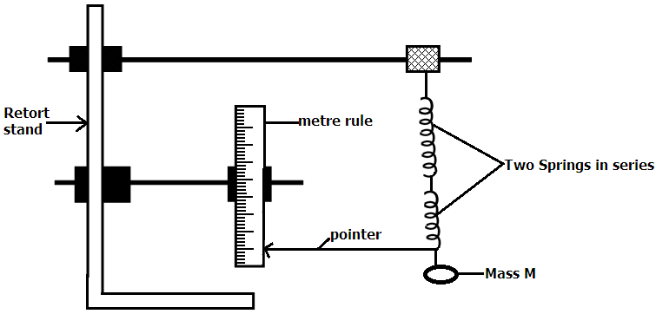

1. Arrange the apparatus as shown in the figure above.
2. With only the springs suspended, read and record the original position Po of the pointer.
3. Hang mass, m = 100g on the spring.
4. Read and record the new position P1 off the pointer.
5. Calculate the extension, e1
6. Remove the mass M
7. Repeat the experiment using Mass M = 300g and record the extension e2.
8. Calculate the spring constant K1 for a single spring from the expression.
$$K_{1}= \frac{3.924}{e_{2}- e_{1}}$$

9. Hang a mass M = 400g on the spring.
10. Pull the mass vertically down wards through a small distance and release it to oscillate.
11. Determine the time for 20 oscillations. Hence find the time T, for one oscillation.
12. Find the value of K2 from
13. Calculate the value of K1 from

**METHODS 2**

1. Rearrange your apparatus with the two similar springs joined in series as shown in the figure below such that the distance $l$ from the 50cm mark C of the metre rule P is 0.100m.

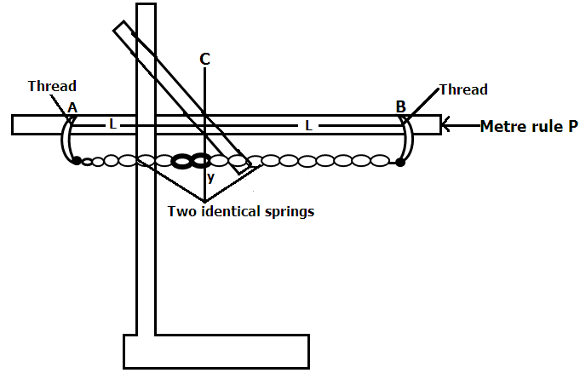

1. Attach amass, M =0.100kg between the two springs.
2. Measure and record the vertical distance y from the point of suspension of the mass M to point C.
3. Repeat procedure (b) and (c) for M = 0.150, 0.200, 0.250, 0.300 and 0.350Kg.
4. Tabulate your results including values of

$β= \sqrt{y^{2}+l^{2}}, w= \left(\frac{β-1}{β}\right)y$ and F = mg, where g=9.81ms-2

1. Plot a graph of F against W
2. Find the slope, s of your graph
3. Calculate the value K2 from
4. Find the value of $|K^{1} – K_{2}| = K$ which is the force constant of a spring.

**No. 2**

In this experiment, you will determine the focal length of the mirror provided

1. Arrange the mounted converging mirror and the optical pin as shown in the figure below so that tip lies along the principal axis of the mirror.
2. Adjust the position of the pin so that the pin coin cides with its image. Measure and record the distance d of the pin from the mirror.

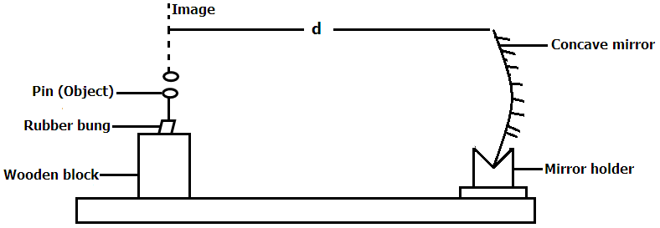

1. Calculate the focal length f, from $f=\frac{d}{2}$
2. Place a pin P1 at a distance 4 $f$ from the mirror.
3. Using the second pin P2, locate the image of P1 formed by the mirror using the method of non-parallax as in figure below.

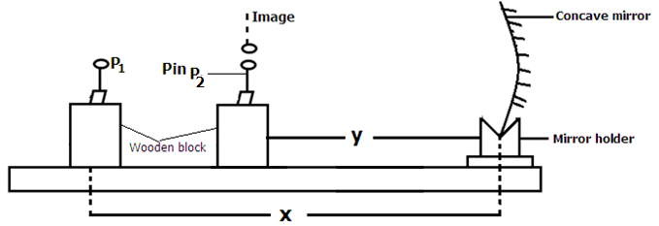

1. Measure and record distances $x$ and $y$
2. Repeat the procedure (c) to $(f)$ for values of $x = 3.5f, 3.0f, 2.5f, 2.0f and 1.5f$
3. Tabulate your results including values of $(x+y)$ and $xy.$
4. Find the slope, $s$ of the graph. Where $s$ is the focal length of the converging mirror provided.

**No. 3**

In this experiment, you will determine the resistivity of the material of a wire $Q$ given by two methods.

**METHOD 1**

1. Connect the dry cell, the Ammeter A and wire Q as shown in the circuit in the figure below.

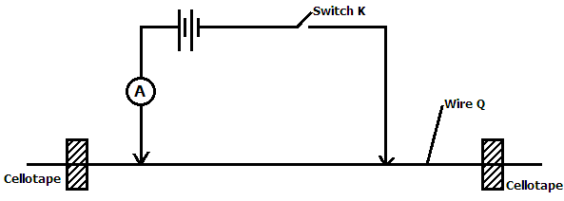

1. Starting $with x_{1} = 20.0cm$, record the reading $i_{1}$ on the Ammeter when $K$ is closed.
2. Open switch $K$.
3. Adjust $x_{2}$ = 70.0cm, read and record the reading $i_{2}$ on the Ammeter when $K$ is closed.
4. Determine P1 from P1 = 1.6 x 10-7 where

, x1 and x2 are in metres.

**Method II**

1. Connect the meter bridge circuit shown in the figure below.

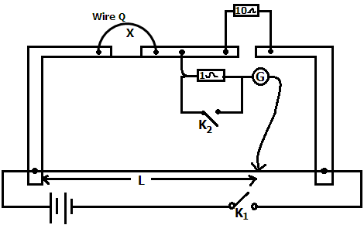

1. Close switch $K_{1}$.
2. Starting with $x = 20.0cm$, find the balance length $l$.
3. Close switch $K_{2}$ and determine accurately the balance length $l$.
4. Repeat procedures (c) to (d) for values of x = 30.0, 40.0, 50.0, 60.0 and 70.0cm.
5. Tabulate your results including values of $\frac{1}{L}$ and $\frac{1}{x}$ in your table.
6. Plot a graph of $\frac{1}{L}$ (along the vertical axis) against $\frac{1}{x}$.(along the horizontal axis)
7. Find the slope s, of your graph
8. Calculate the resistance per metre length $σ$ of Q from the expression $σ$ = $\frac{1}{s}$
9. Calculate the mean diameter D of the wire Q.
10. Find the resistivity P of the material of the wire from the expression.

$$P= \frac{σπD^{2}}{4}$$

**END**